Using the SnagIt Screen Capture Tool as a Support Associate at xyz Corp.

Mike Yakavonis

Contents

Introduction: 2

Why Should I Use SnagIt? 2

Daily roles and responsibilities as a Support Associate 2

Target Audience 3

What does the ticketing process entail and what role does SnagIt play? 3

The job will get done sooner or later -- why such an emphasis on including effective screenshots with support tickets? 3

Types of Client support 4

Supporting newly-implemented Clients 4

Weekly status calls with Clients 4

Fielding Client inquiries into the Zendesk ticketing portal 4

Capturing an Image 5

Manipulating an Image 6

Optimizing SnagIt for the Support Associate role 7

Exporting a Capture to Another Program 7

SnagIt: Coming Attractions 8

Index 9

# Introduction:

This manual teaches effective SnagIt practices so you can unlock its full potential and perform job duties more efficiently. It will also assist you in mastering the broader responsibilities of the Support Associate role at xyz Corp.

## Why Should I Use SnagIt?

As a Support Associate at *xyz Corp.,* you take a high volume of screenshots. The reasons may vary, but the overarching goal remains the same: contribute to a sleeker and more robust product for our Clients. Whether the situation calls for reporting User Interface bugs, documenting Clients' system enhancement requests, or general upkeep, you will have frequent need to convey detailed screen captures to database developers.

# Daily roles and responsibilities as a Support Associate

A significant part of a Support Associate's role involves documenting database errors so developers can pinpoint the root cause. The most common tool you will use for efficient image capture is SnagIt software. This manual is intended for new employees so you can overcome the typical learning curve attached to SnagIt and achieve quicker outcomes for Clients. It will also provide you a roadmap for effectively delivering Client support at xyz Corp.

## Target Audience

New Support Associates -- you should consult this guide AFTER you become familiar with the company's ticketing system interface, as well as the software itself. [Reference: TicketingSystemGuide.PPT]

You are the Client's initial point of contact anytime they discover a database bug or brainstorm an idea for a system enhancement.

## What does the ticketing process entail and what role does SnagIt play?

*Definition:* Agile/Scrum Team - A type of software organization structured around continuous enhancement projects completed in pre-scheduled cycles, known as *sprints*.

Since xyz Corp. operates as an Agile/Scrum team, you must submit a ticket to be tracked in the company's ticketing system anytime a Client request will modify some aspect of the database. Once a ticket is submitted, a Product Owner evaluates the ticket and determines the request's difficulty. The Product Owner then assigns the ticket to the relevant development team.

As the development team works on a ticket, they will often pose clarifying questions to you, the Business Resource, prior to deploying a fix. This promotes a more efficient resolution with less back and forth correspondence. Once the developers complete the fix, they will release it into our test database. Your job is to test their work and decide if it satisfies the request. [For guidance on solution acceptance testing, consult the relevant regression test script, hosted on the Company S: Drive.

If the proposed fix does not solve the problem, you must demonstrate why the developers need to review their work. And since seeing is believing, screenshots are the number one way to prove your point. Depending on a ticket's complexity, there is potential for several exchanges between you and development. Given the high volume of screenshots required, SnagIt enables our team to reach a solution sooner.

The job will get done sooner or later -- why such an emphasis on including effective screenshots with support tickets?

There is no handbook written from the support associate's perspective. Your process differs from any other team using the ticketing system. You are on the frontlines with a client who is expecting timely resolution, and the turnaround depends on your ability to convey their request efficiently.

Ultimately, when you unleash the power of SnagIt, it makes your job easier. And who wouldn't want that? As you will learn throughout this guide, SnagIt offers several features and shortcuts tailormade for the Agile process.

# Types of Client support

Before we explore the features of SnagIt, you will need an understanding of the three primary modes of providing tech support at xyz Corp:

## Supporting newly-implemented Clients

As new clients are onboarded, a handoff takes place between the Implementation Team and our team. During this transfer of responsibility, you will address any lingering knowledge gaps a Client has with our software's functionality. In addition, as they acclimate to the software, it is often at this stage the Client realizes their software needs further tweaks or customizations. While some requirements will be quick fixes to turnaround, others can only be deployed within a Sprint cycle. Therefore, it is important to set the Client's expectations accordingly.

## Weekly status calls with Clients

These recurring meetings will be your most consistent communication with Clients. It is an opportunity to talk through ongoing support issues, as well as resolve new ones in real-time. You might use SnagIt in this forum to document software bugs seen on a Client's screen.

## Fielding Client inquiries into the Zendesk ticketing portal

* *Note: The Zendesk portal is distinct from our internal ticketing system, which is used strictly to submit requests to development. Zendesk is an interactive, Client-facing platform used to initiate and manage support requests.*

Zendesk inquiries run the gamut of potential Client needs. Oftentimes, Clients are simply confused about the software's capability, or how they see it fitting within their organization's internal process. You will learn to distinguish requests that do not need the development team's involvement from those that are valid concerns.

*You can consult the table below to assist in determining the best course of action:*

| If the ticket involves a **bug**... | If the ticket involves an **enhancement**... |
| --- | --- |
| * Can I reproduce the client's error on my own, or will I need them to demo? * Has another client reported the same bug in the past? * Is the bug preventing them from completing their daily work? (is it a showstopper?) | * Can the client's goal be achieved another way they may not be aware of? * Is the request reasonable? (sound business case) * Have we developed a similar solution for a previous client? If yes, can we leverage it? |

# Capturing an Image

When SnagIt first launches, a command menu displays on your screen. From here, you can configure several pre-capture filters and other settings, or advance directly to the Editing module:

1. To immediately enter screen capturing mode, click the Red 'Capture' button.

*Hint: As a shortcut, you can also press the Print Screen button on your keyboard to activate capture mode.*

A dotted crosshairs grid spans the screen.

1. To select the area you wish to include in the capture, hover until all content is located within the illuminated portion of the screen.
2. Click on the desktop to toggle the capture panel:

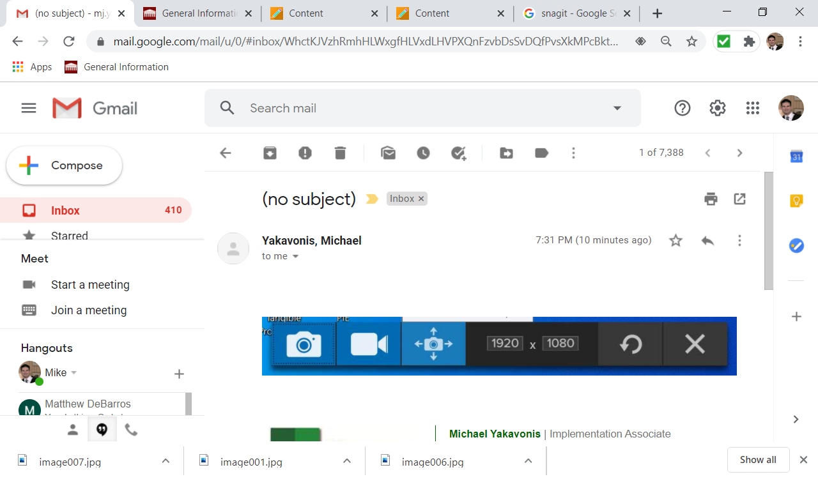

You can capture content in three ways:

* Take a traditional screenshot.
* Record a brief video.
* If the content spans multiple sections of a screen, take a panoramic scroll capture.

1. Once you determine the appropriate capture method, click the corresponding icon above.

* Each capture will automatically import into the *SnagIt Editor*, where you can refine the content.

# Manipulating an Image

* To crop the image, drag the square handles.
* To shrink or magnify the original content at scale, choose a percentage value:

SnagIt features various image formatting and annotation options.

Below are selected examples to familiarize you with major features. For thorough descriptions of all features, reference TechSmith's available documentation and video tutorials:

|  |  |  |  |  |  |  |  |  |  |  |  |  |  |  |
| --- | --- | --- | --- | --- | --- | --- | --- | --- | --- | --- | --- | --- | --- | --- |
| |  |  | | --- | --- | | Option | Description | | Arrow | Point out a specific feature or area within the image. | | Callout | Emphasize a certain element within the content. | | Text | Detail the action to be taken, or in the case of a software bug, identify what is supposed to occur. | | Shape | Highlight an object referenced in the body of your Support Ticket. | | Cut Out | Remove an irrelevant portion of the image, or join together disconnected content. | | Eraser | Remove portions of the graphic entirely, or reverse an edit you already made. | |

With several of these objects, a sidebar opens at right, allowing you to customize the effect.

# Optimizing SnagIt for the Support Associate role

Although the development team writes the database scripts behind the scenes that keep our software running, they will not always be as expert as you from the UI perspective. So, while your ticket may seem obvious, do not look past some of the ways SnagIt can minimize misinterpretation and drive home a point. Let's explore specific features from the preceding list you will access often in your role, and describe the scenarios where they will be most useful:

* *Cut Out*

Cut Out will prove especially helpful when Clients request an enhancement to the UI. With Cut Out, you can assist developers in visualizing how they should best approach the ticket and demonstrate how the end result should appear.

* *Text*

*Text* is one of SnagIt's more versatile effects. If a Client reports a software bug, development will need to understand exactly which area is malfunctioning, and sometimes objects (such as an arrow) cannot fully depict the error. Text is also handy in telling a User's story. In other words, describing the sequence of events behind the User's ultimate goal.

# Exporting a Capture to Another Program

SnagIt is integrated with common file transfer and MS Office programs, so you can share captures across applications. This allows you to insert an image directly into another application you are working in.

1. Click the 'Share' button, located at the top right of SnagIt Editor.
2. Choose the desired destination program.

A banner message will appear at the bottom of your screen, indicating whether the import was successful. The destination app does not need to be one of the choices listed above -- you can always copy [control + C] the content to your computer's clipboard and paste into another program.

*NOTE: No need to 'save' once you have imported an image into SnagIt editor -- the SnagIt library will store your 24 most recent captures*.

# SnagIt: Coming Attractions

In the 2021 version release of the latest SnagIt software, new functionality will allow Users to easily create technical support materials and how-to guides. Rather than exporting multiple captures into another application (think: PowerPoint), you will be able to design ad hoc User guides in a slideshow format that can be quickly shared. The upcoming enhancement will be welcome news for those of you delivering Client refresher trainings, since materials created in SnagIt *Create* module can be distributed among several Clients to reinforce your live sessions.

Be on the lookout for updates to this guide that explore this and other valuable, time-saving SnagIt tips and tricks.

# Index

Image

capture, *5*

export, *7*

manipulation, *5*

Support

types. *See* ticketing

Support team

procedure, 3

structure, 3

Ticket

entry, 3

testing, 3

writing, 3

Ticketing

development process, *3*

Internal, *3*

justifications, *5*